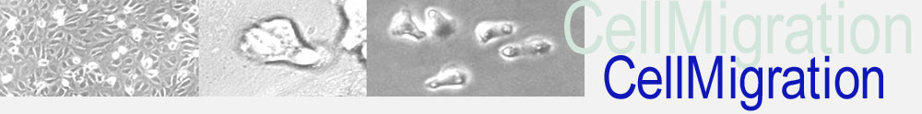

Registration for the PhD Program Cell Migration

“Cell Migration in Immunosurveillance, Inflammation, Tumorigenesis and Metastasis”

1. Personal data
Last name |  |  | First name
Supervisor |  |  | E-mail
Co-Advisor |  |  | E-mail
Mentor |  |  | E-mail
Starting date of PhD studies
Thesis Title
Institute
Office
address
Zip code |  | City
Phone |  | Mobile
E-mail |  |  |  | Matriculation no.
For students of the University of Bern: The PhD Program Cell Migration cooperates with the Graduate School for Cellular and Biomedical Sciences of the University of Bern (GCB). PhD students in this program benefit from an interdisciplinary education organized by national experts in the field. Students enrolled in the PhD program Cell Migration gain 10 ECTS to graduate from the GCB and to fulfil the requirements of the PhD program Cell Migration. The certificate of the PhD program Cell Migration will be issued after graduation from the GCB and is valid only in combination with the graduation certificate of the GCB of the University of Bern.

2. Signatures
PhD Student
- With my signature, I agree on the exchange of personal data between my university / the GCB and the PhD program cell migration.
- A short description about the role of cell migration for my PhD project is enclosed (max 500 words).

Place, date |  | Signature

Supervisor and Mentor
Supervisor |  | Mentor
Place, date |  | Place, date

Please send this form to Britta Engelhardt (britta.engelhardt@unibe.ch) and the admin team (sekretariat.tki@unibe.ch)

