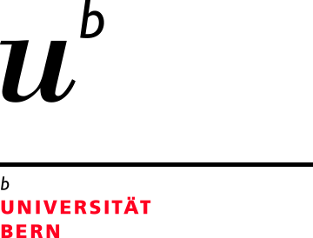

PhD Student (100%) Molecular Endocrinology in Bern, Switzerland

We are looking for a PhD student to join the Translational Hormone Research Program in the Department of Pediatrics and Department of BioMedical Research at the University of Bern, Switzerland. We are an international and dynamic team, with the research focus on the molecular biology and biochemistry of steroid hormones, and how these hormones regulate endocrine-linked diseases and disorders. We therefore study variations in human steroid disorders by a series of cell biological and biochemical methods, and analytical techniques.

We offer a stimulating international environment, with state-of-the-art facilities and an integrative training program, which includes molecular biology techniques, bioinformatic tools, cell biological assays and mass spectrometry.

Qualifications and skills

- Master degree in Biochemistry, Pharmacology, Molecular Biology or Life Sciences.
- Candidate should be eligible for registration as a PhD student at the Graduate School for Cellular and Biomedical Sciences of the University of Bern (www.gcb.unibe.ch)
- Good communication and social skills and ability to work independently.
- Fluency in English (verbal & written) is mandatory as the laboratory language is English.

The position is available from April 2024 or later, with a negotiable starting date, and is offered for three years. The PhD salary will be according to the scale of the Swiss National Science Foundation.

Candidates should be able to come for a personal interview to Bern, Switzerland and, therefore, only candidates currently living in Switzerland or in an EU country will be considered.

Please send your application including a letter of motivation and curriculum vitae with two to three referees to Prof. Christa E. Flück, PI of Pediatric Steroid Research at christa.flueck@unibe.ch.

