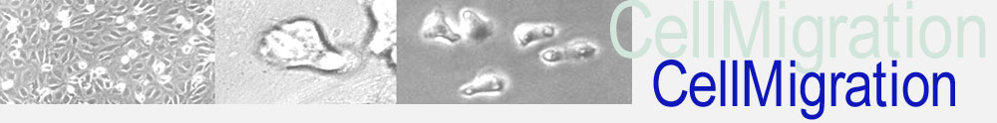
Individual Curriculum for (first name, family name):
starting the PhD program Cell Migration on (insert the appropriate date):
This document is continuously updated by the students themselves.
Students are obliged to complete this form and send it to Prof. Britta Engelhardt (britta.engelhardt@unibe.ch) and the admin team (sekretariat.tki@unibe.ch) before completing the PhD program Cell Migration.
The dates of mid-term and final exams as well as for the thesis defense must be forwarded to Prof. Britta Engelhardt and the admin team at least four weeks in advance.

Mandatory Courses
Semester  Date | General Courses outside of PhD Cell Migration Curriculum (up to 3 ECTS) | ECTS

Date | PhD Cell Migration Curriculum – Lecture Courses (at least 3 ECTS). | ECTS
Date | PhD Cell Migration Curriculum – Practical Classes (at least 2 ECTS). | ECTS
Date | PhD Cell Migration Curriculum – Journal Clubs (at least 2 ECTS). | ECTS

Additional lectures, seminars, courses, workshops
Date | Description

Meetings / Conferences
Date | Description

Presentations
Date | Description

Comments: (type your comments)

Date: …………………………………………………………………….

Signature:

